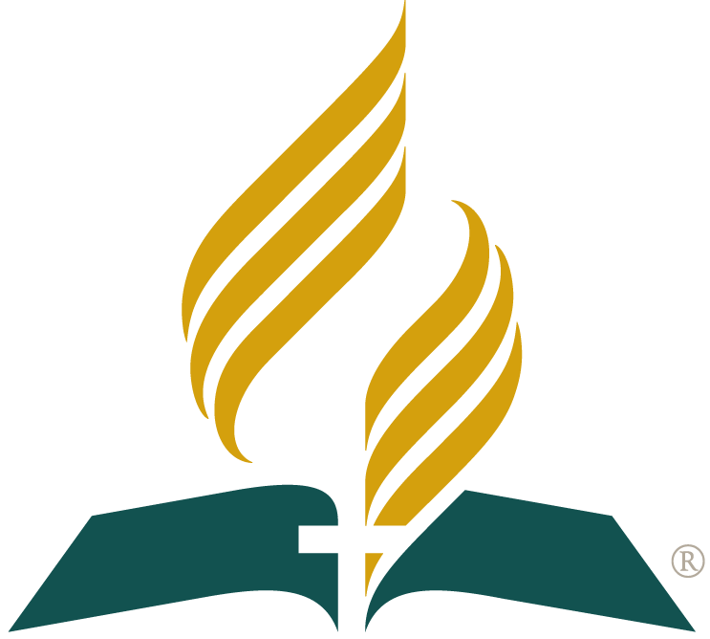

Welcome !
SDA Hiroshima
English Church
Bulletin

Saturday, 1 November 2008
Number 5

Today

Today's program will include singing, prayer, music and a message from the Bible.

Message

Brad will share today’s message from the Bible entitled, “What is Christian?” The talk will explain a bit about what Christianity is and what a Christian’s life is like.

About

The SDA (Seventh-day Adventist) Hiroshima English Church is a community of people wanting to know and share the good news about God and Jesus Christ through the Bible.
It is operated by the SDA Hiroshima English School. It is part of a world-wide network of churches, schools, universities, medical institutions and welfare agencies which help people in everyday life.

Programs & Events

English Sabbath School - at church, 1F
Bible Discussion, Songs & Prayer
Every Saturday, 9:50 am - 10:30 am.

English Church (Japanese translation), 1F
Bible Message, Songs & Prayer
Today, 11 am - 12:00 noon
Next English Church: Sat 7 February 2009.

English Conversation Class (Free!)
Improve your English using Bible stories.
Contact us for your first free lesson!

Softball Sports Day - at Nishi-ku
1 pm – 5 pm, Sunday 2 November.

Ten-pin Bowling Sports Night - at Naka-ku
6:00 pm, Saturday 15 November

Hearts For Eternity - at church, 2F
1:30 pm, Saturday 15 & Sunday 16 Nov.
Know how you can have friends forever. Prepare for the future and eternity.

Services

We also provide free Bible studies for
individuals and small groups, in English or Japanese, in homes or at church. Ask us!
If you want to listen to previous English Church messages, please ask us for a CD or download it from our website (see below).

Access

1 Floor, SDA Hiroshima Church
4-4 Takeya-cho, Naka-ku, Hiroshima
Web: sdah.org
Email: sda_hiroshima@yahoo.co.jp
Phone: 082-241-2464 or 082-245-0514
__ I would like to learn more about the Bible, God, Jesus, church or about today’s talk

__ I would like to study English conversation at the free English Bible classes

__ I would like to be contacted about social, sports, health, music or youth events

Name: ______________________________________ Tel: ____________________________

Email: ________________________________________________________________________

Welcome !
SDA Hiroshima
English Church
Bulletin

Saturday, 1 November 2008
Number 5

Today

Today's program will include singing, prayer, music and a message from the Bible.

Message

Brad will share today’s message from the Bible entitled, “What is Christian?” The talk will explain a bit about what Christianity is and what a Christian’s life is like.

About

The SDA (Seventh-day Adventist) Hiroshima English Church is a community of people wanting to know and share the good news about God and Jesus Christ through the Bible.
It is operated by the SDA Hiroshima English School. It is part of a world-wide network of churches, schools, universities, medical institutions and welfare agencies which help people in everyday life.

Programs & Events

English Sabbath School - at church, 1F
Bible Discussion, Songs & Prayer
Every Saturday, 9:50 am - 10:30 am.

English Church (Japanese translation), 1F
Bible Message, Songs & Prayer
Today, 11 am - 12:00 noon
Next English Church: Sat 7 February 2009.

English Conversation Class (Free!)
Improve your English using Bible stories.
Contact us for your first free lesson!

Softball Sports Day - at Nishi-ku
1 pm – 5 pm, Sunday 2 November.

Ten-pin Bowling Sports Night - at Naka-ku
6:00 pm, Saturday 15 November

Hearts For Eternity - at church, 2F
1:30 pm, Saturday 15 & Sunday 16 Nov.
Know how you can have friends forever. Prepare for the future and eternity.

Services

We also provide free Bible studies for
individuals and small groups, in English or Japanese, in homes or at church. Ask us!
If you want to listen to previous English Church messages, please ask us for a CD or download it from our website (see below).

Access

1 Floor, SDA Hiroshima Church
4-4 Takeya-cho, Naka-ku, Hiroshima
Web: sdah.org
Email: sda_hiroshima@yahoo.co.jp
Phone: 082-241-2464 or 082-245-0514
__ I would like to learn more about the Bible, God, Jesus, church or about today’s talk

__ I would like to study English conversation at the free English Bible classes

__ I would like to be contacted about social, sports, health, music or youth events

Name: ______________________________________ Tel: ____________________________

Email: ________________________________________________________________________

